**The Best Free and Open Source Fashion Design Software**

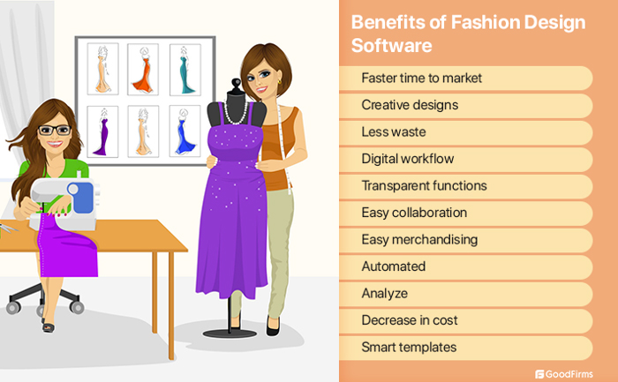

### **1. Digital Fashion Pro**

**Purpose:** Professional Digital Fashion Sketching & Illustration / Helps With Starting a Fashion Brand

**Features:** Create Technical Sketches / Aids In Apparel Production

**Features:** Design Menswear, Women’s Wear, Kid’s Wear, Baby Clothing, Handbags, Shoes, Accessories

**Features:** Includes Hundreds of Digital Fabrics & Textile Prints

**Features:** Includes Training Specific to Core Functions of Designing a Clothing Line

**Features:** Easy-To-Learn & Use, Beginner-Friendly

**Features:** You do not have to know how to draw to create professional fashion sketches with DFP

**Technical Support Cost:** Free Lifetime Support by phone and email

**Comes With Free Training:** Yes. Videos and e-Training Guide

**Requires Internet To Use**: No

**System Requirements:** Windows, Mac, Chromebook

### **2. Adobe Illustrator**

**Purpose:** General Vector Graphics Editor

**Features:** Create Digital Artwork, Textile Designs, Apparel Designs

**Includes Garment Templates & Models:** No

**What Can You Design With It?** Anything But User Has To Create Everything From Scratch

**Technical Support Cost:** Fee

**Comes With Free Training:** General How To But Not Specifically related to garment design

**Requires Internet To Use**: Yes

### **3. Corel Draw**

**Purpose:** General Vector Graphics Editor

**Features:** Create Artwork & Textiles

**Includes Garment Templates & Models:** No

**What Can You Design With It?** Anything But User Has To Create Everything From Scratch

**Technical Support Cost:** Fee

**Comes With Free Training:** General How To But Not Specifically related to garment design

**System Requirements:** Windows Or Mac

### **4. Optitex**

**Purpose:** 2D & 3D Fashion Design

**Features:** Integratable With Adobe Illustrator

**Features:** Pattern Making

**Includes Garment Templates & Models:** Yes

**Technical Support Cost:** Fee

**Comes With Free Training:** Fee

### **5. Browzwear**

**Purpose:** 3D Fashion Design

**Features:** Turn a Design Into a Tech Pack

**Includes Garment Templates & Models:** Yes. Limited.

**Technical Support Cost:** Fee

**Comes With Free Training:** Yes

**Requires Internet To Use**: Yes

### **6. Clo 3D**

**Purpose:** Garment Design & Pattern Making

**Features:** Imports 3D Body Scans

**Features:** Can Be Implemented Into A Website For Virtual Fittings

**Includes Garment Templates & Models:** No

**Technical Support Cost:** Free

**Comes With Free Training:** Yes

**System Requirements:** Windows Or Mac

### **7. C-Design**

**Purpose:** Fashion Design & Collection Management

**Features:** Helps In Garment Creation Cycle

**Features:** Can Integrate With Adobe Illustrator and Corel Draw

**Includes Garment Templates & Models:** Yes

**What Can You Design With It?** Apparel

**Technical Support Cost:** Unknown

**Requires Internet To Use**: Yes + Windows Or For Mac Users – Need Windows + Parallels

### **8. TUKA3D**

**Purpose:** 3D Fashion Design & Garment Development Software

**Features:** Full Motion Simulation

**Features:** Fabric Simulation

**Includes Garment Templates & Models:** Yes

**Technical Support Cost:** Free

**Comes With Free Training:** Yes

**System Requirements:** Windows PC or Laptop

https://startingaclothingline.com/best-fashion-design-software/